FDA approves next phase of stem cell research
by RANDY WELLS on January 29, 2015 10:59 AM
Indiana-based clinical research company Antria Inc. has been given the green light by the U.S. Food and Drug Administration for the next step in medical research to help patients look younger through cosmetic surgery that uses their own stem cells.
Products and procedures being developed by Antria may also eventually relieve joint pain for arthritis sufferers and offer women an alternative for breast augmentation and reconstruction.
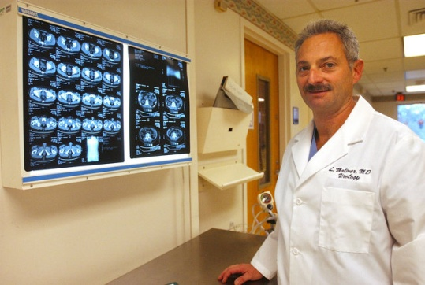
Indiana urologist Dr. Leonard Maliver, one of the company’s founders and its CEO, said Antria is the first company to gain FDA approval to begin Phase II clinical trials with autologous adipose-derived stem cells (ADSC) — stem cells taken from the same patient’s fat stores — for plastic surgery.
“ADSCs are one of the most promising avenues of medical research to use the stem cells of patients to create a more natural, longer-lasting youthful look than traditional cosmetic surgery,” Maliver said.
Stem cells are unspecialized cells capable of renewing themselves through cell division, and, under certain physiologic or experimental conditions, can be induced to become tissue- or organ-specific cells with special functions. In many tissues they serve as an internal repair system, dividing to replenish other cells, and each new cell has the potential either to remain a stem cell or become another type of cell with a more specialized function, such as a muscle cell, a red blood cell or a brain cell.
Antria’s patent-pending process uses liposuction to extract a patient’s own fat, typically from the belly, thighs or hips. Within an hour, stem cells are prepared from that material and clinicians then inject the stem cells under the patient’s facial skin as part of the procedure to reduce the appearance of wrinkles, scars and sagging skin.
“It’s all done in the operating room at the same time” as the cosmetic surgical procedure, he said.
In Antria’s Phase I research completed last year, stem cells were used in facial augmentation procedures on six patients and the FDA monitored their recoveries and outcomes.
“Essentially there were no undue adverse side effects and everyone did well cosmetically and physiologically,” Maliver said.
Phase II may take two years and may involve about 34 patients. It will be a double-blind controlled study in which some patients receive just fat grafts and some will receive fat grafts augmented with Antria’s stem cell process.
“The idea is to show that the patients who received the fat with the stem cells do a lot better than the patients who just received the fat,” Maliver said.
The Phase II trials will probably be conducted in plastic surgeons’ offices in Gainesville, Fla., and possibly in Greensburg. It’s also possible, Maliver said, the FDA will not require a third phase of trials, or may allow Phase III to be combined with Phase II.
Assuming the study is successful and shows what Maliver said has been demonstrated in other countries, the FDA may grant Antria clearance to sell its new product commercially in America.
The product is a kit that will contain chemicals and reagents needed to convert a patient’s own fat into active stem cells without contaminants.
“There have been many companies trying to do what we’ve done that have spent over a quarter of a billion dollars trying to get through Phase I, and we’re a tiny little company based in Indiana, Pa., financed by friends and family for under $2 million that has done this. So it’s a David and Goliath story,” Maliver said.
According to Antria, the company’s product and procedure for isolating stem cells from adult fat may have potential applications beyond cosmetic surgery and may also help with wound healing and might bring relief to patients with multiple sclerosis, impotence and urinary incontinence.
Another application may be for the treatment of arthritis.
“These same stem cells tend to want to become cartilage cells when they’re put into joints,” Maliver said.
“The same process we use now — to inject into faces for plastic surgery procedures — we plan on going back to the FDA and get approval to start injecting these same stem cells derived from the same patient’s fat and using it to augment breasts,” Maliver said. “Women now are having artificial implants put in, and instead of having that we can come out with a kit so that they can use their own fat to make their breasts larger.”
More importantly, he said, Antria’s process may be a technique for reconstructing breasts after breast cancer surgery.
Phase II trials are expected to start in the next two to three months, Maliver said. If the FDA requires a Phase III trial it may involve 100 or more patients.
The Antria partners are now looking for institutional investors for the company’s research and development efforts.
The other physicians among Antria’s founders are Indiana orthopedic surgeon Dr. David Bizousky and general surgeon Dr. Shah Rahimian, of Florida, who has also been a consultant for the biomedical industry throughout North America, Asia and Europe, according to Antria.

